# **Adding java-script to our web-site**

## **Inline java-script**

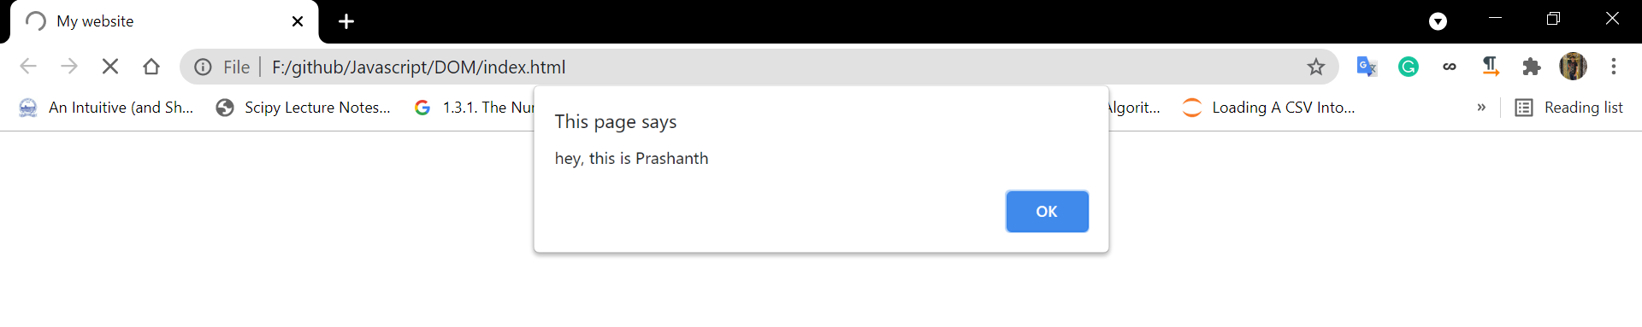  
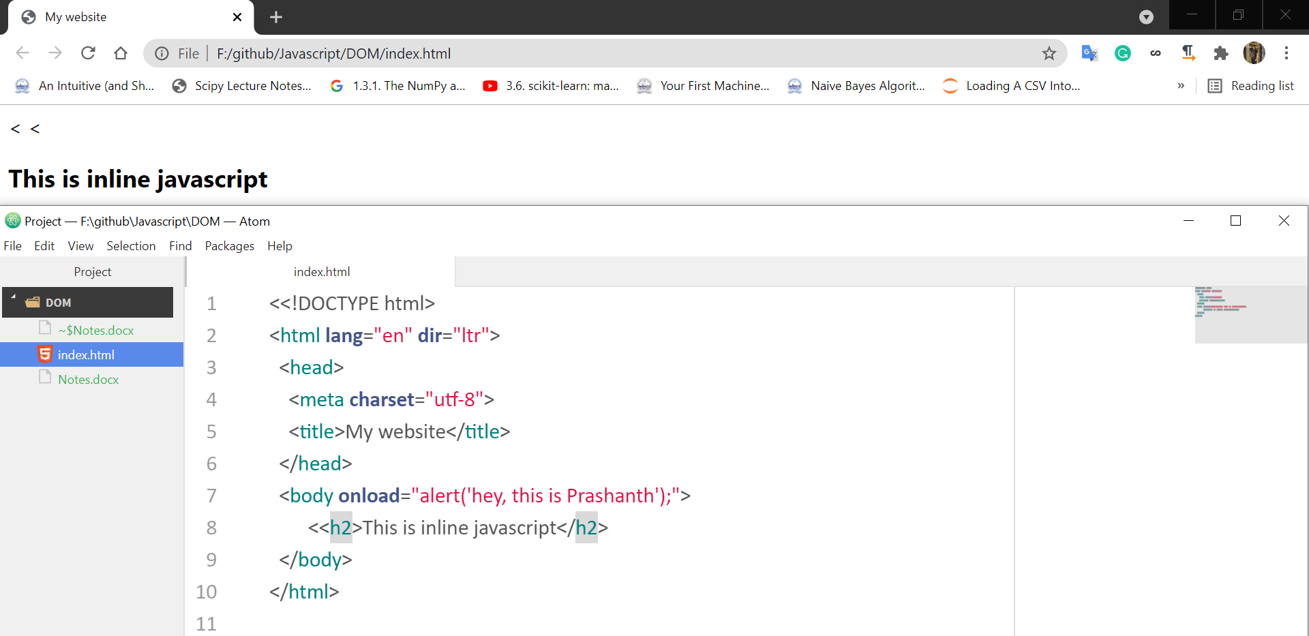

## **Inserting via script java-script**

## **Inserting java-script via external file**

# **Position of java-script and CSS in the HTML file**

Position of css doesn’t matter but position of java-script matters a lot.

## **CSS placed in the bottom**

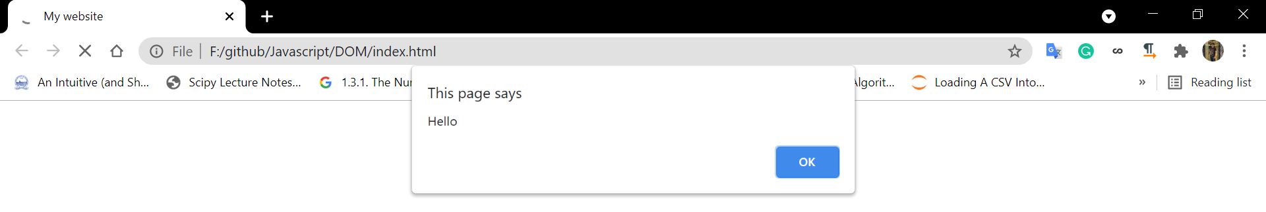  
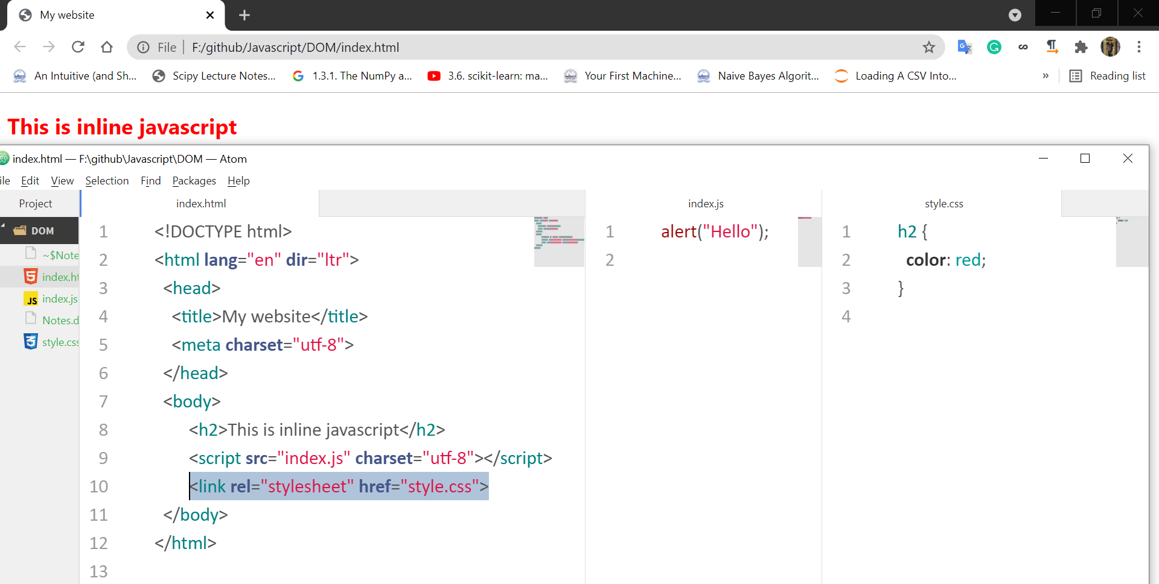

After clicking OK, red colour on the text appears.

## **CSS placed in the top**

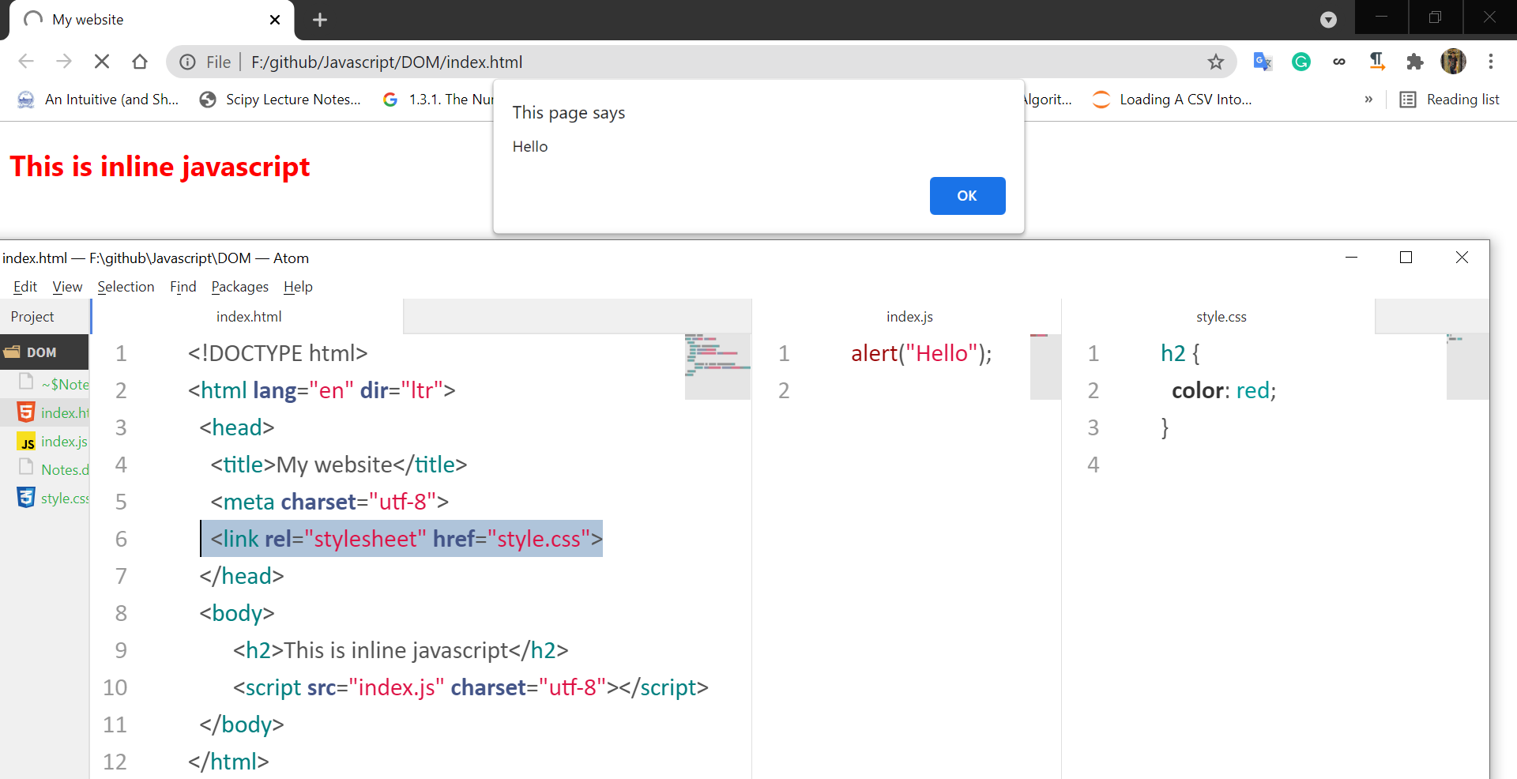

Before clicking OK, red colour text appears.  
So in-order to make the colour appear, **css should be placed in the top.**

## **Java-Script placed in the top**

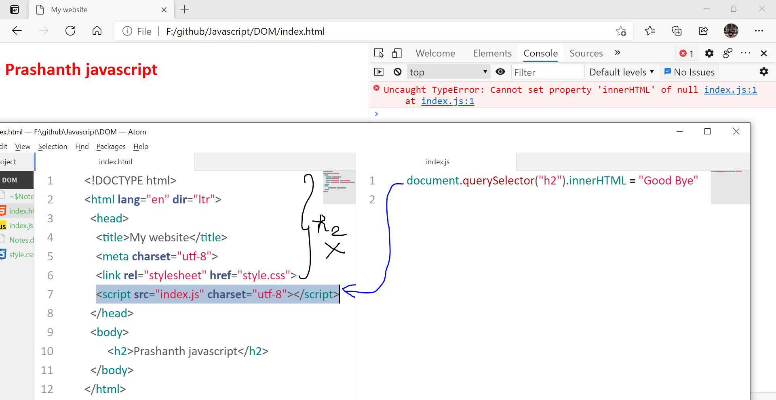

Looks for h2 in index.html, but h2 doesn’t found so error.

## **Java-Script placed in the bottom**

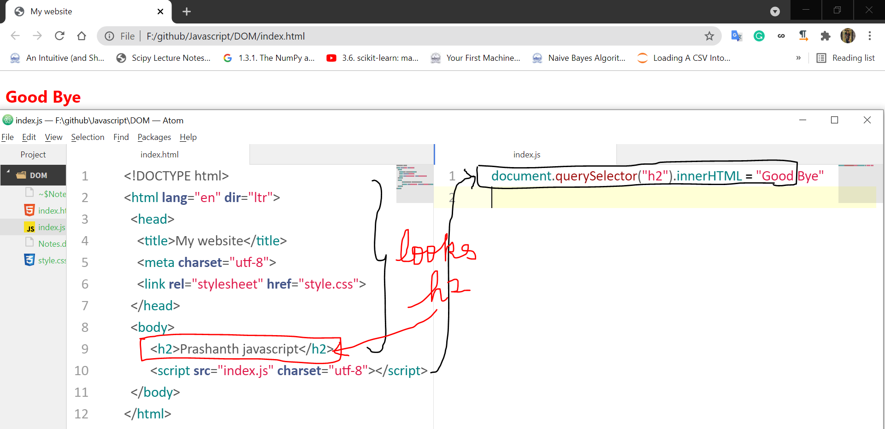

Looks for h2 in index.html, after seeing h2 the text is changed to “Good Bye”  
So in-order to make apply all the effects, **java-script should be placed in the bottom.**

**CSS 🡪 TOP  
Java-Script 🡪 BOTTOM**

# **DOM Introduction**

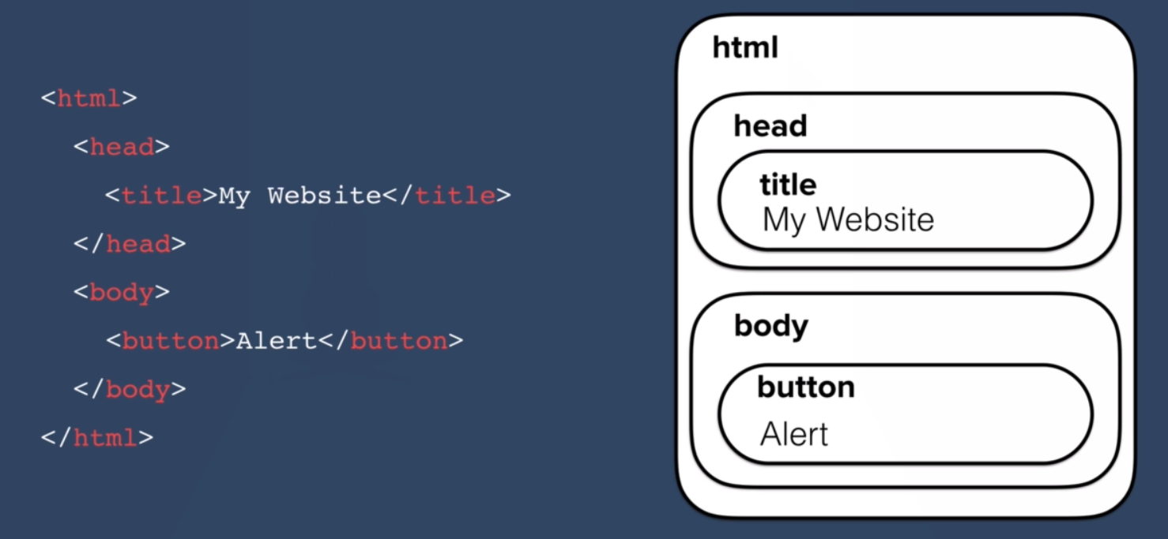

Turns each of the elements and their associated data into a tree structure with a whole bunch of objects that you can select and manipulate.

DOM representation 🡪 all the html elements have been converted into objects and their relationships to-each other are mapped out in the tree diagram.

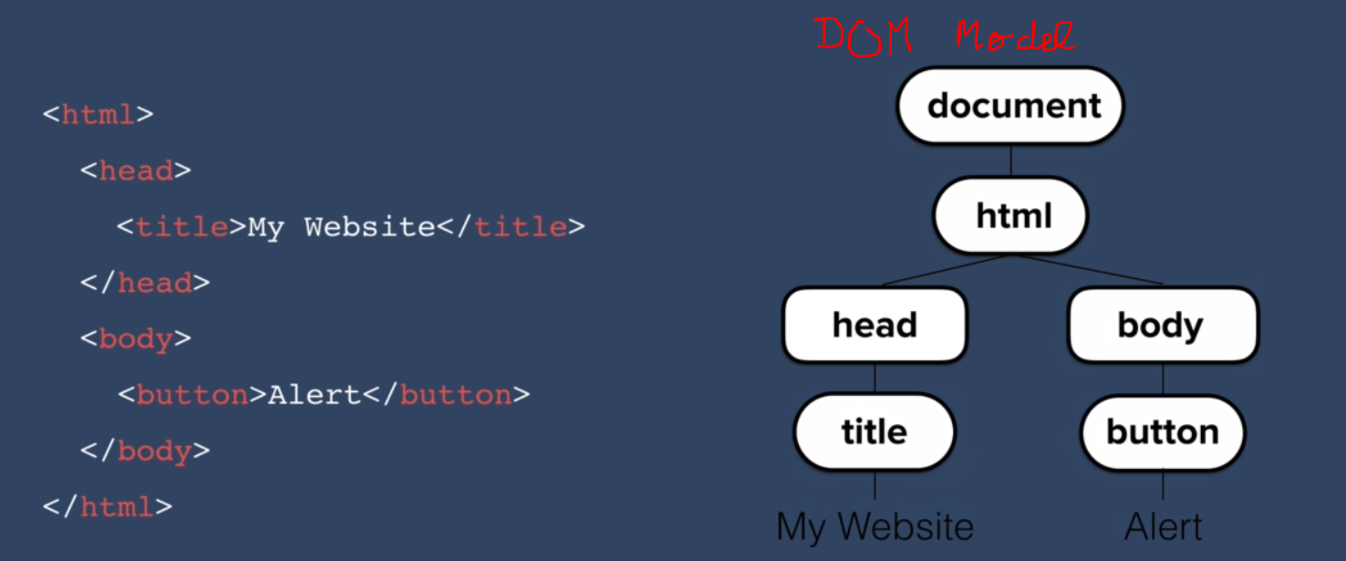

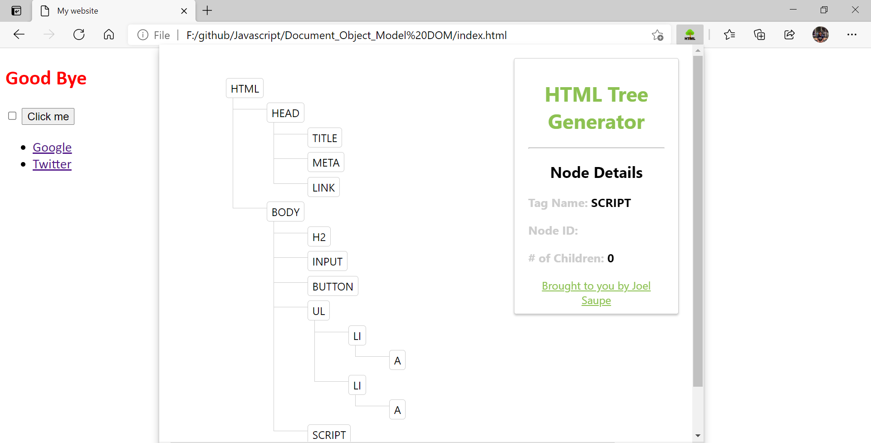

## **Accessing the individual objects through java-script**

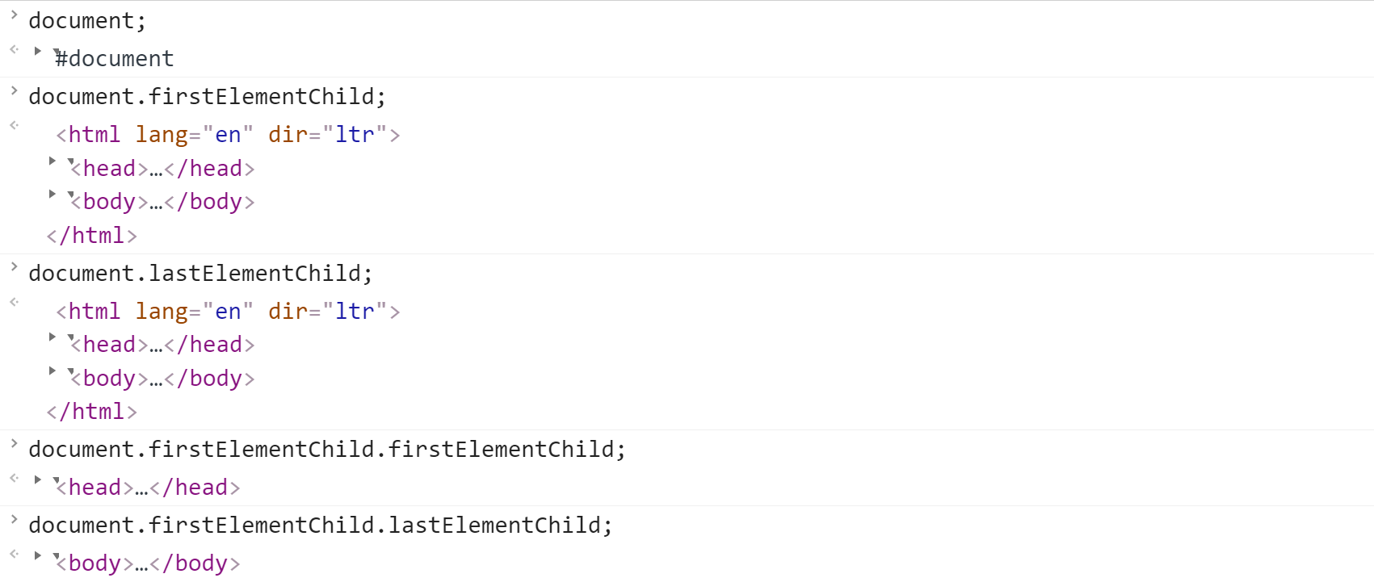  
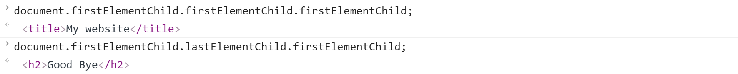

## **Manipulating individual objects**

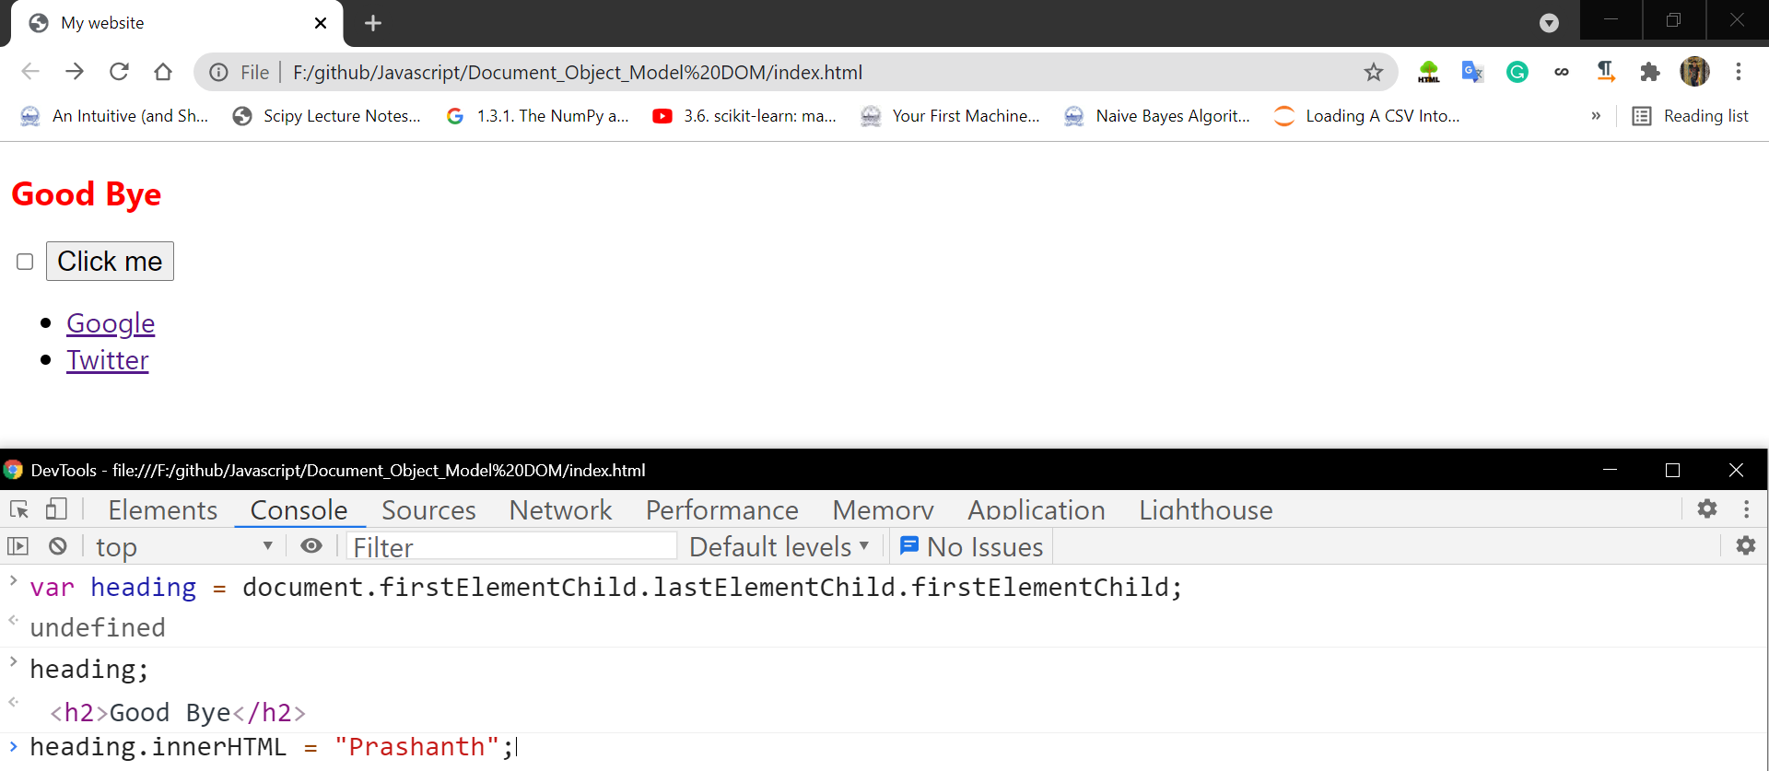After clicking enter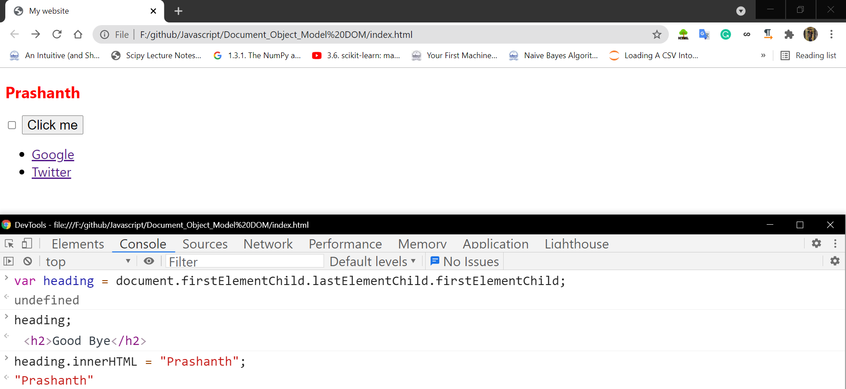Changing the color

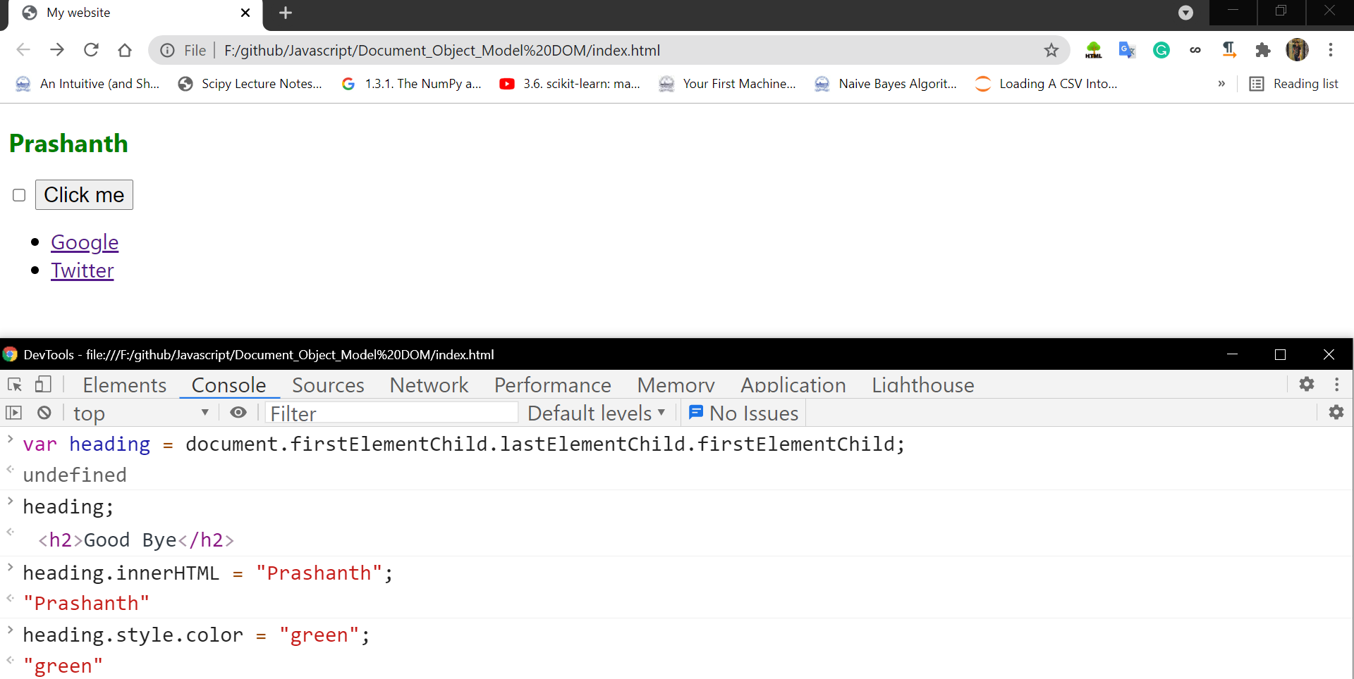

Without making a click directly on the checkbox from the mouse, we can make it via querySelector.

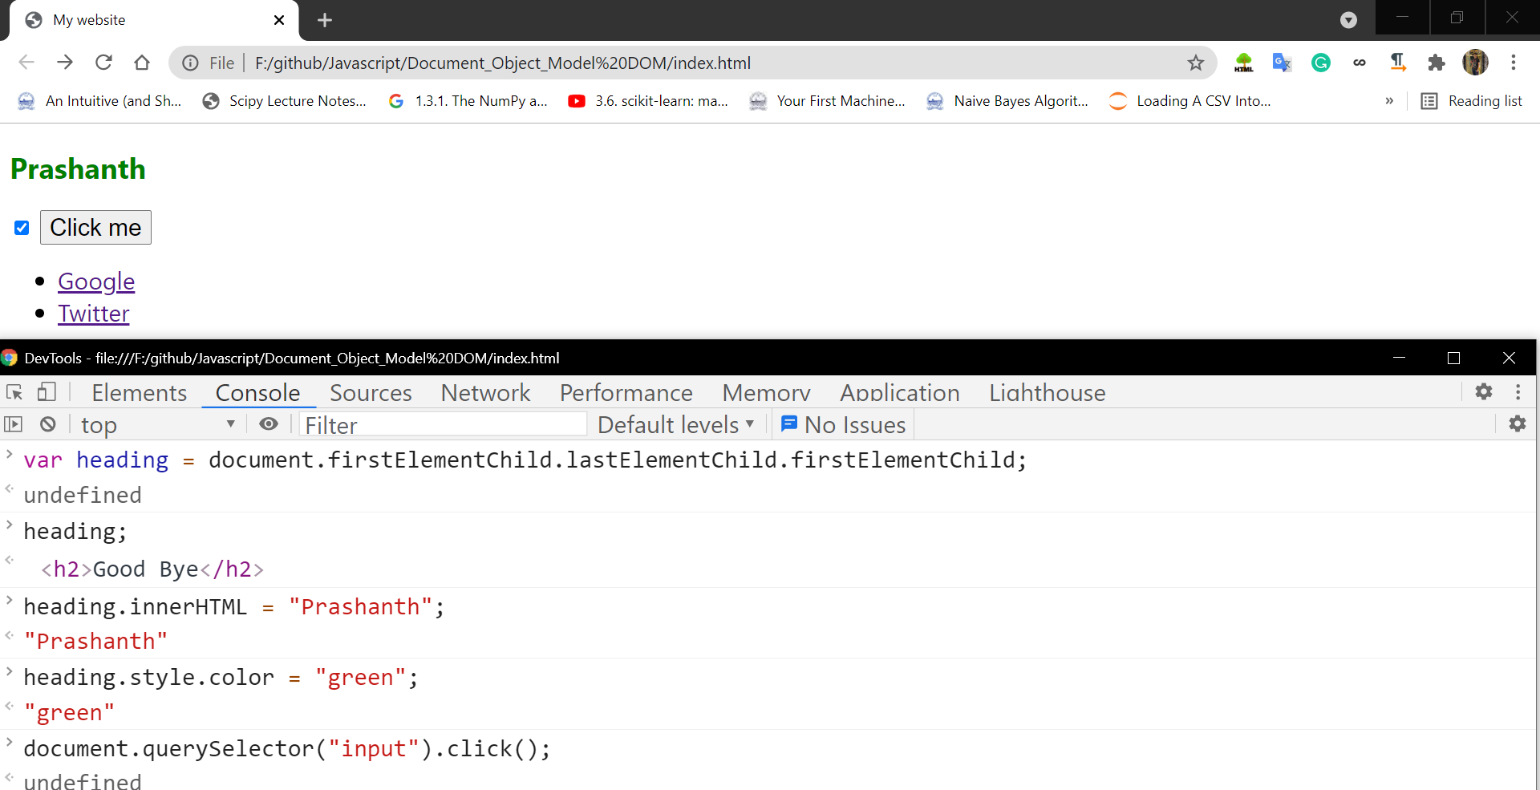

## **Properties and Methods**

Objects inside the DOM can have properties and methods

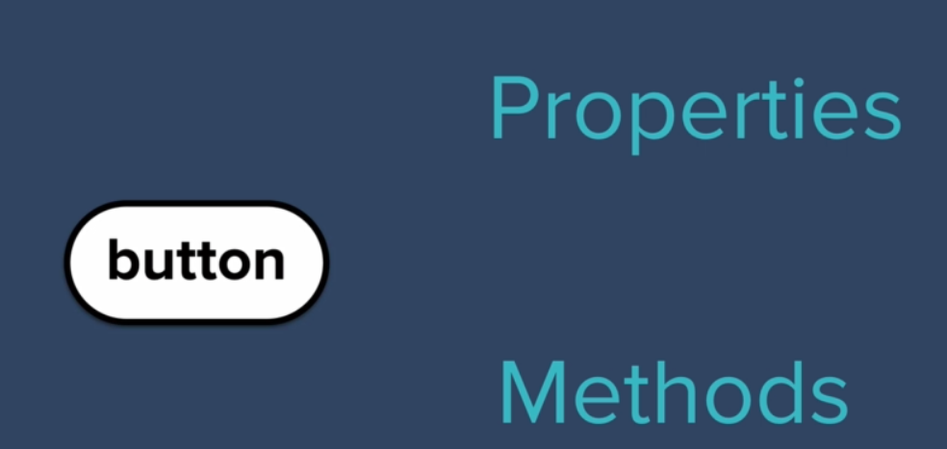

Here the object is button.

Properties 🡪 Describes something about that object.  
Method 🡪 Other things that the object can do.

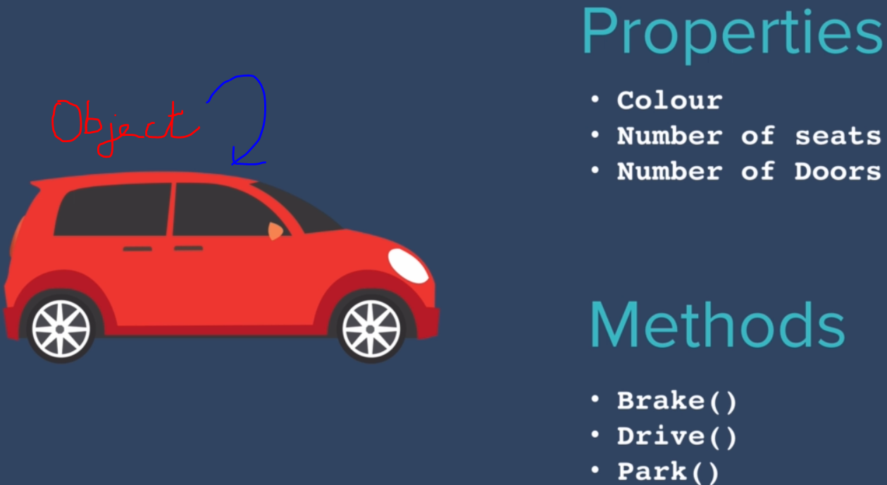



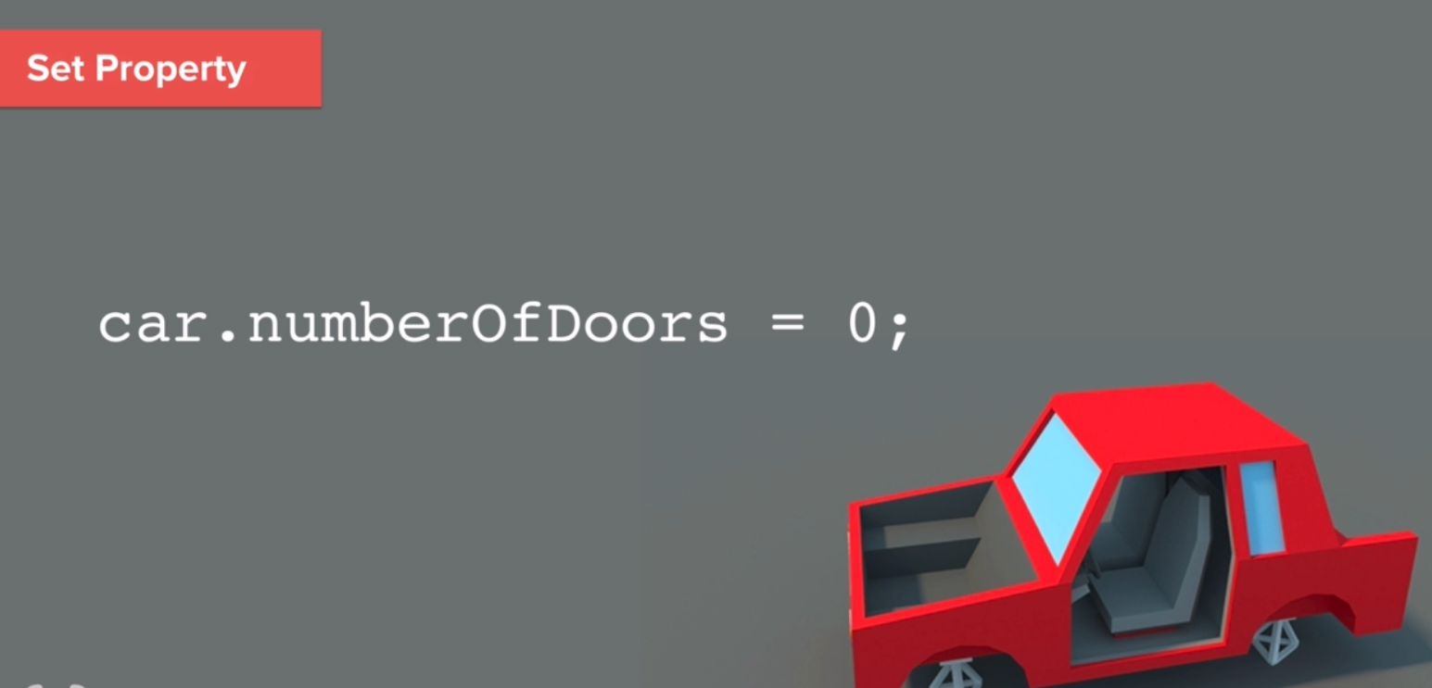

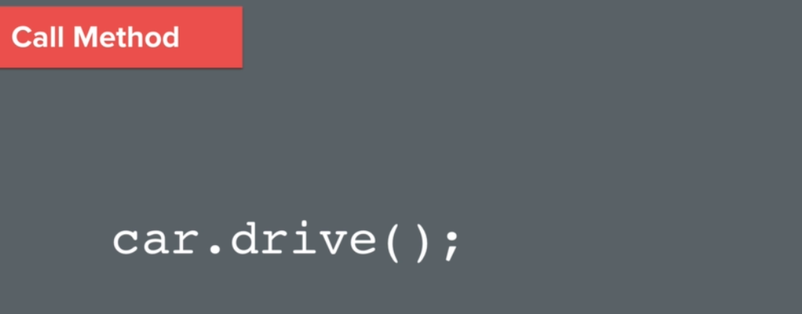

Method 🡪 associated with objects.  
Functions 🡪 doesn’t associated with objects.  
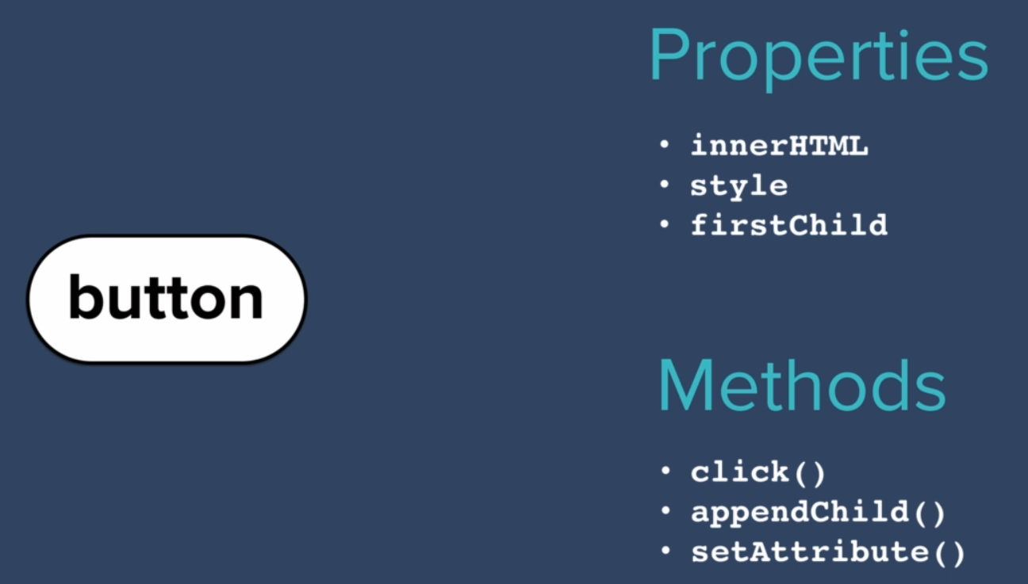

## **Challenge [You to Youtube]**

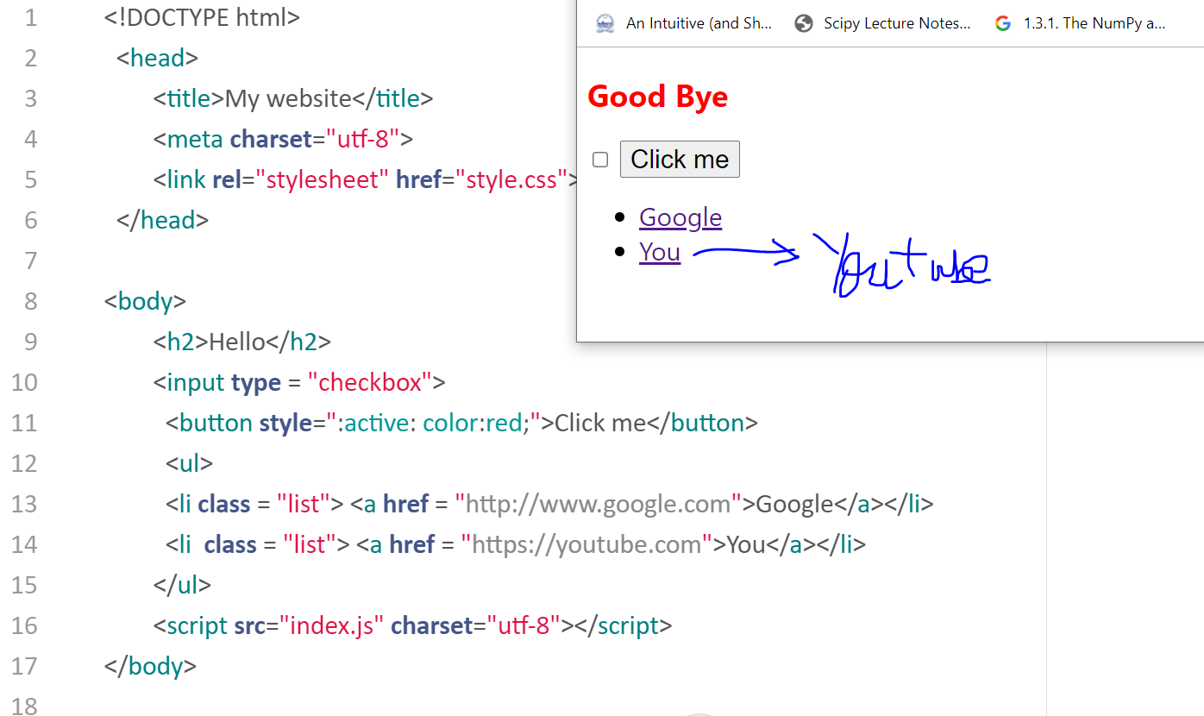

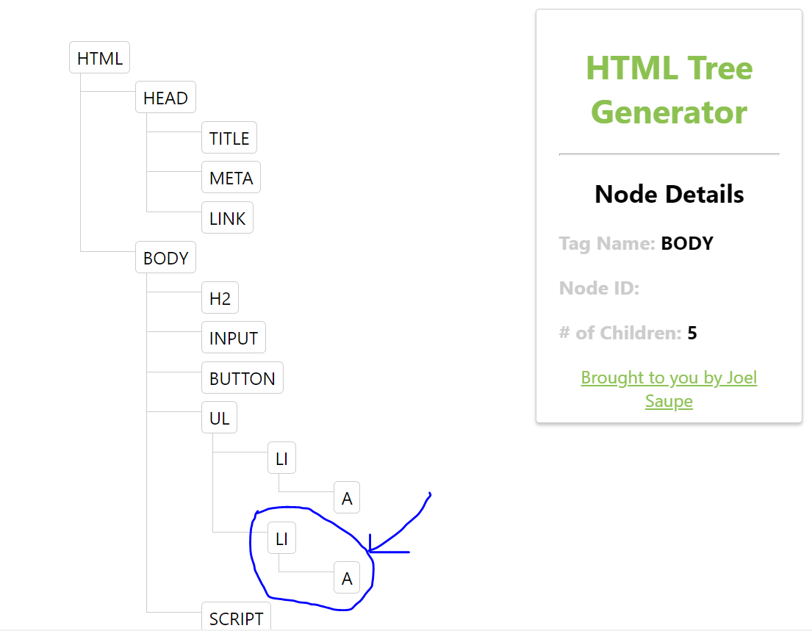

Since there is no way to select the elements individually, its better to use ID for selecting the elements.

## **Accessing the elements using html tag name**

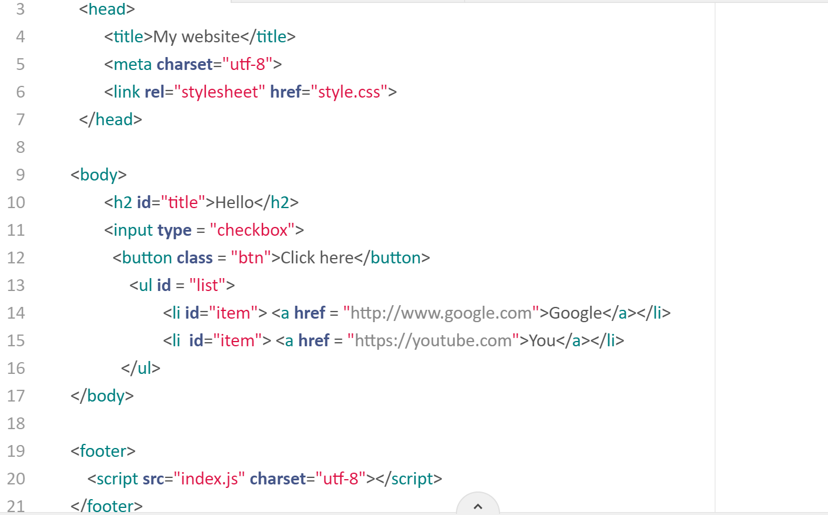

***document.getElementsByTagName() 🡪 plural***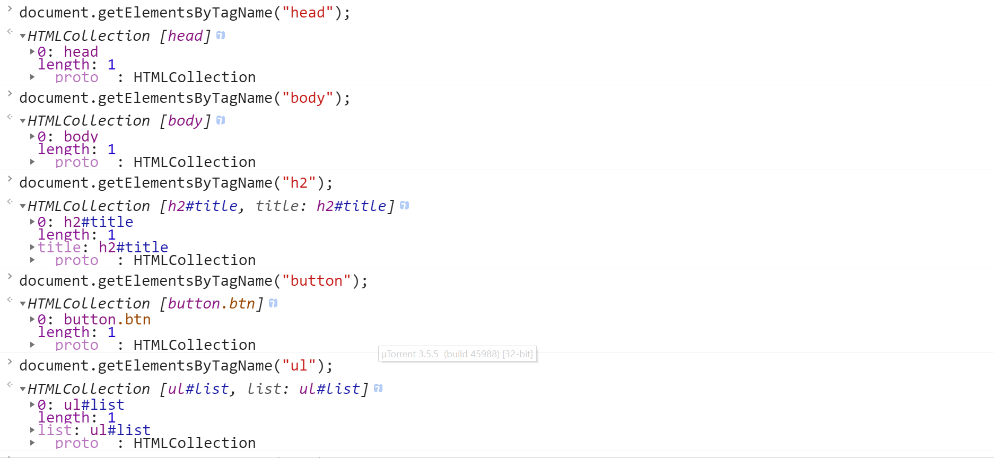  
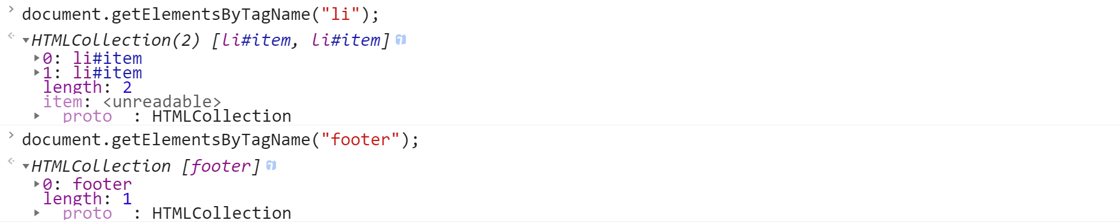

Get the number of li elements.

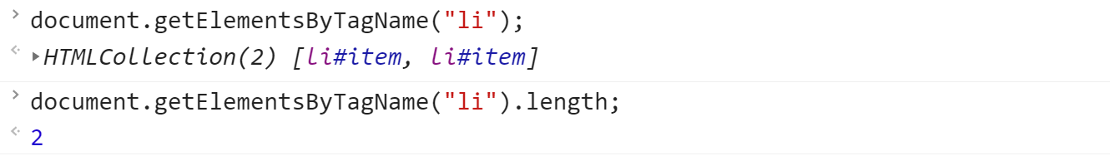

Set the color of 2nd li element to green

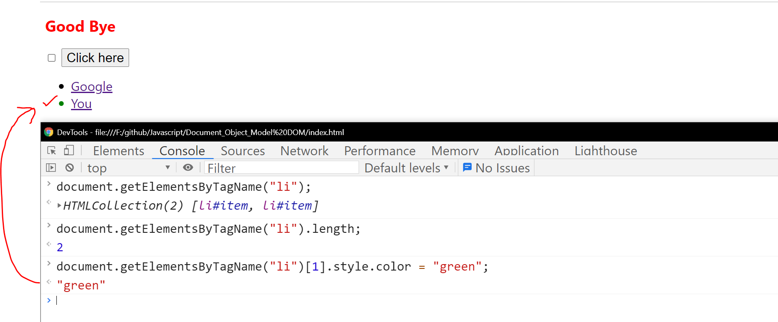

## **Accessing the elements using class name**

***document.getElementsByClassName() 🡪 plural***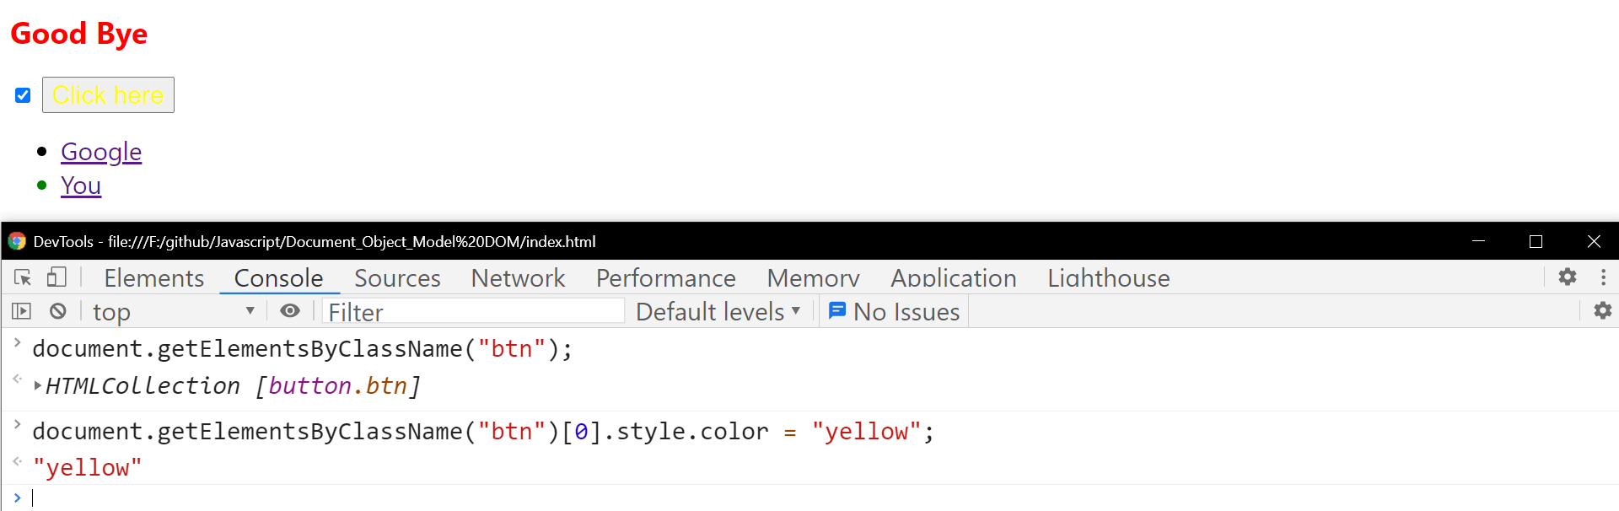

Though there is only a single button class, but also the class elements must be accessed only via index.

## **Accessing the element using id**

***document.getElementById() 🡪 singular***

Since ID is unique to each and every element in the html page.

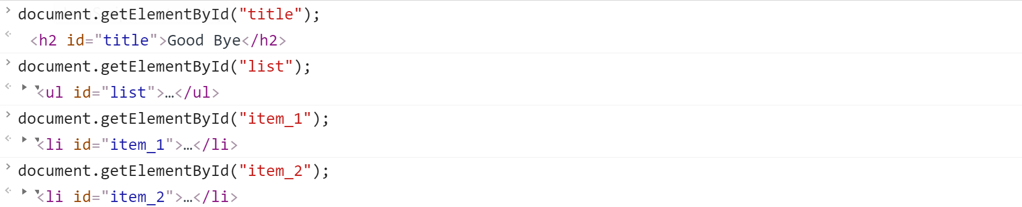

Change the title name 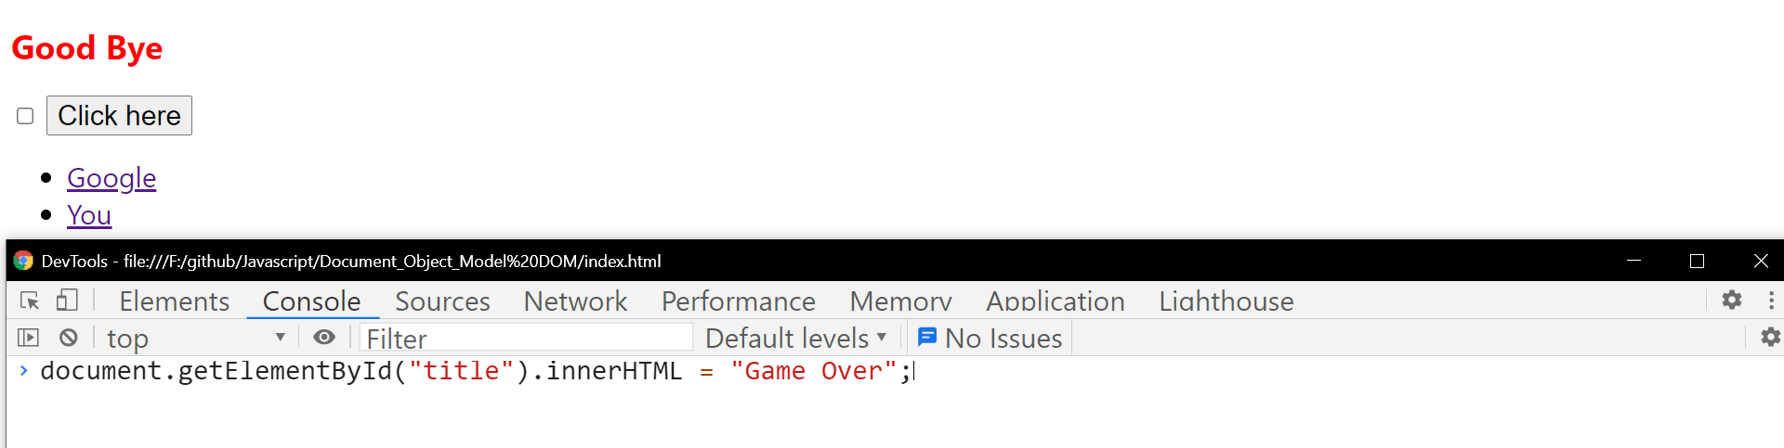

After clicking enter

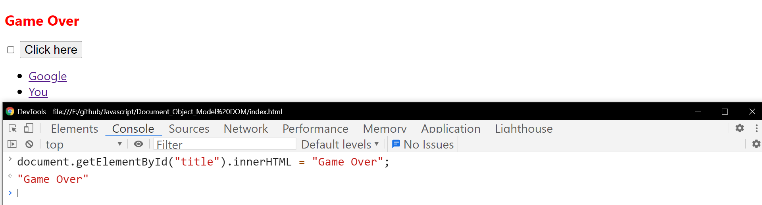

## **Accessing the element using querySelector()**

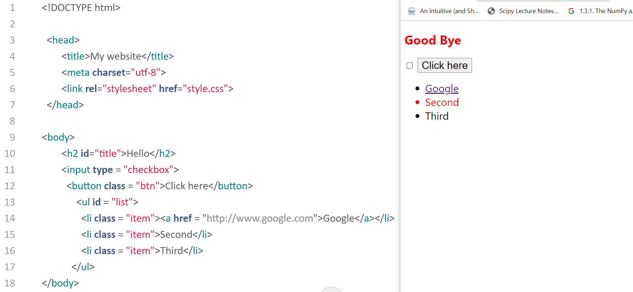

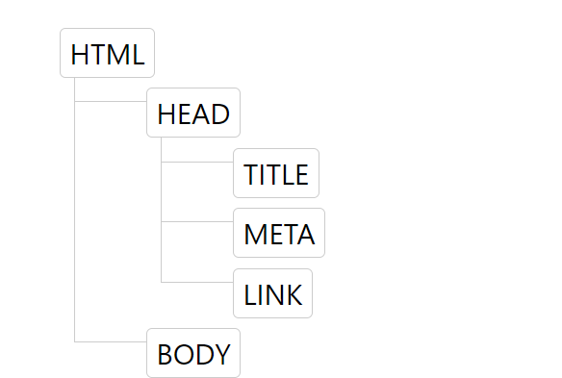  
 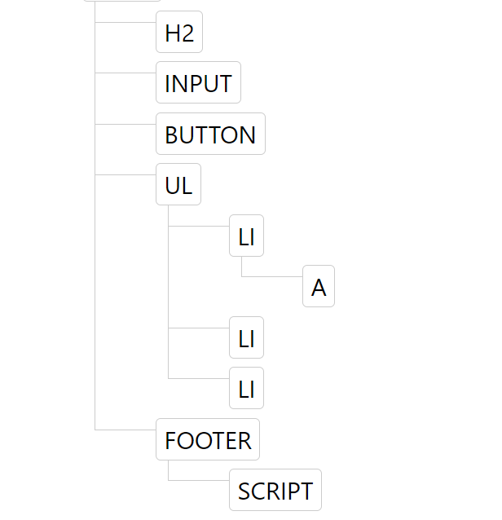

Accessing the tag = tag_name  
Accessing the Id = #.id_name  
Accessing the Class = .class_name

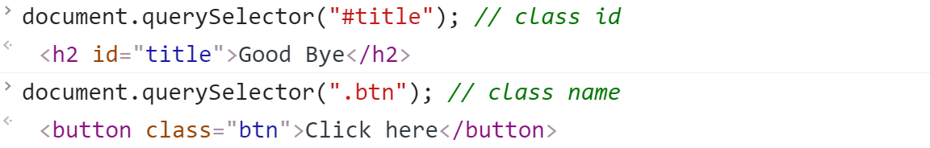

Only tags 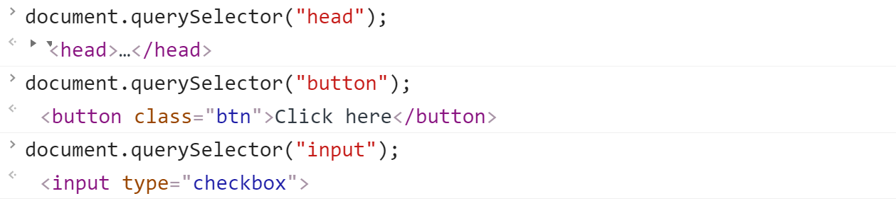

tags inside a specific tag

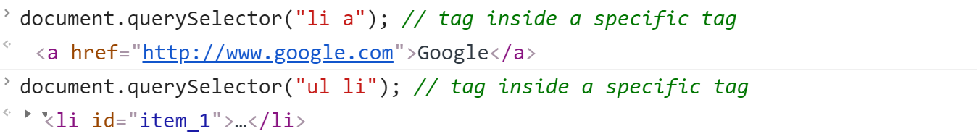

tags with id name

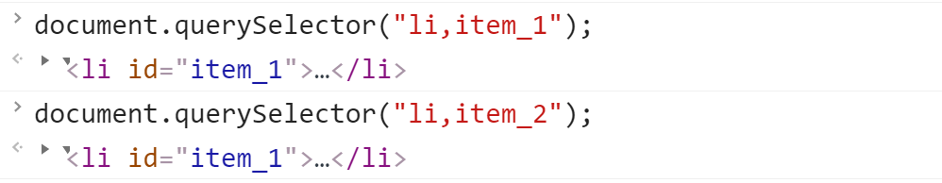

Looking for an anker tag which is inside the list item



Id and class

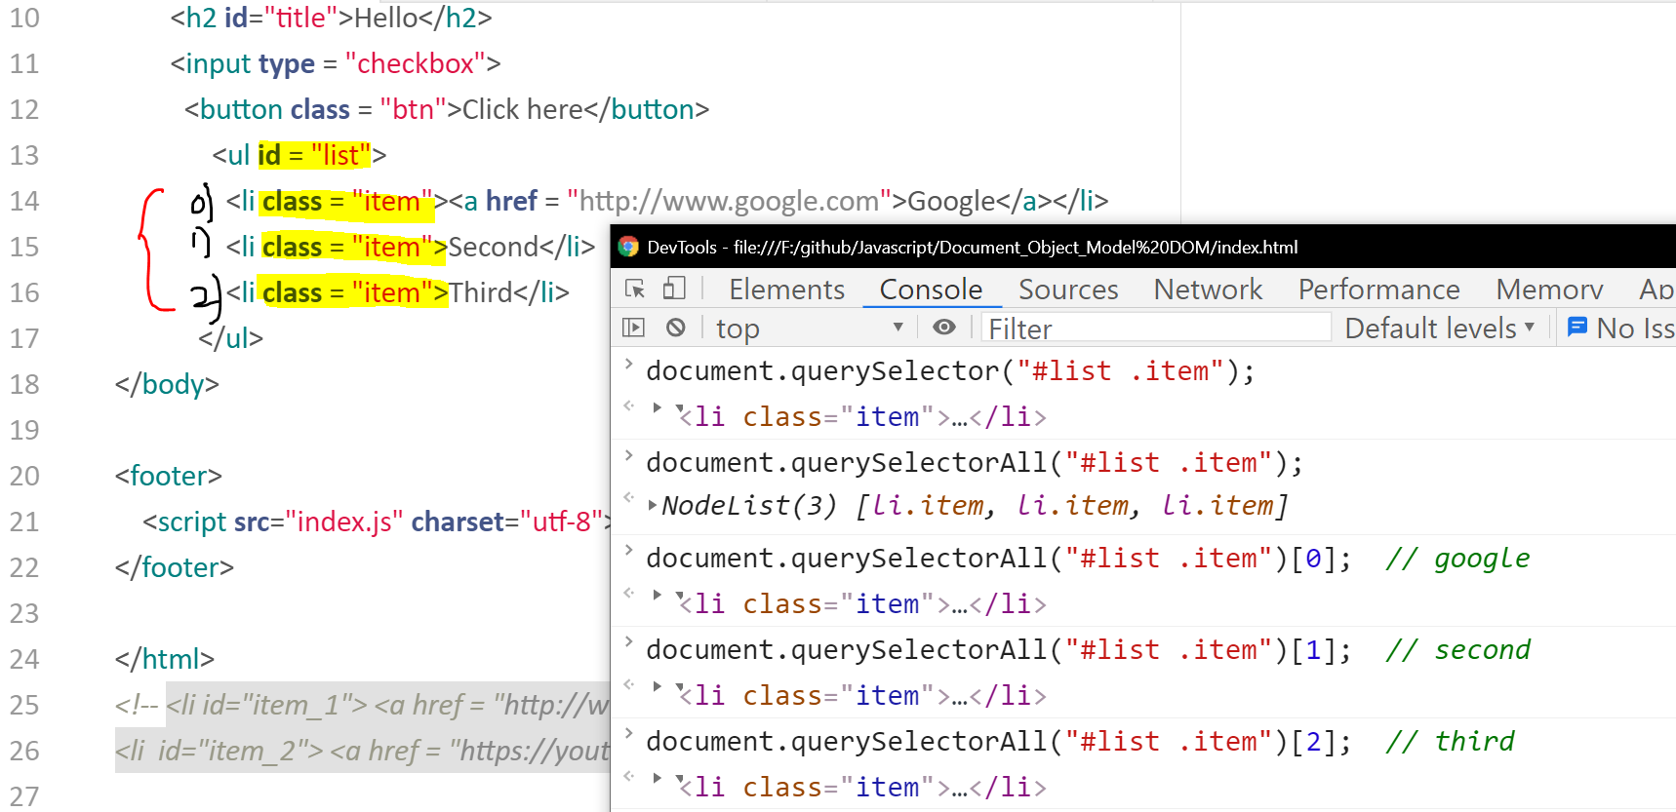

Changing the second color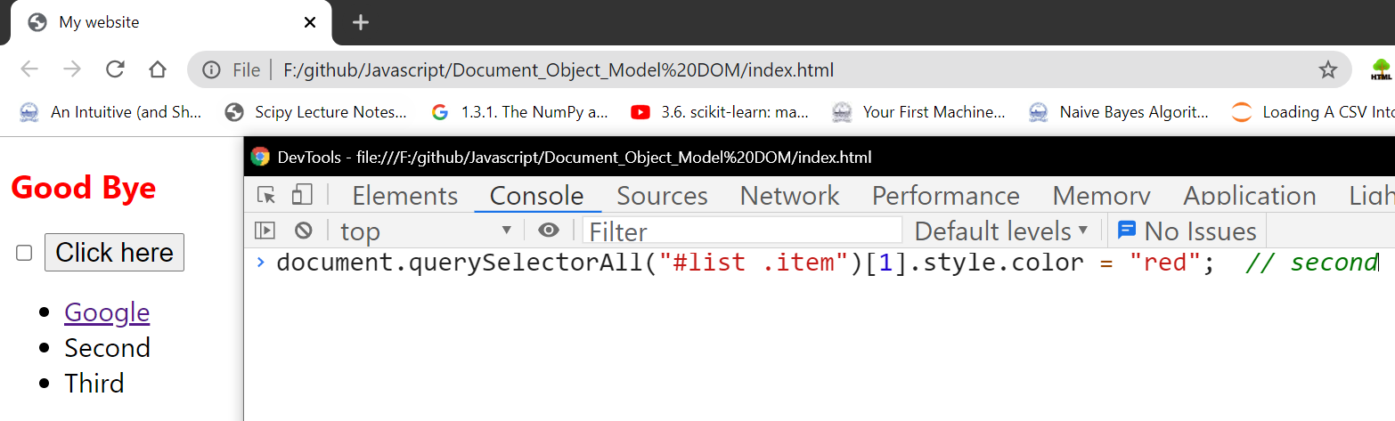

After clicking enter

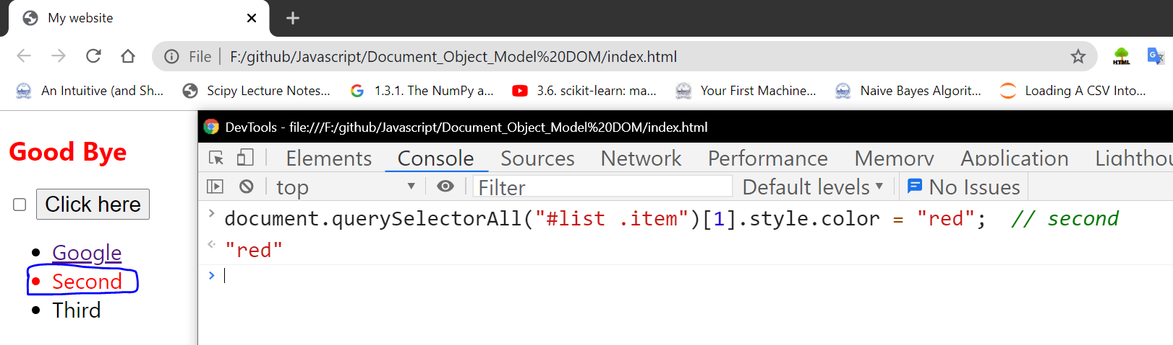

Change the google link color to red

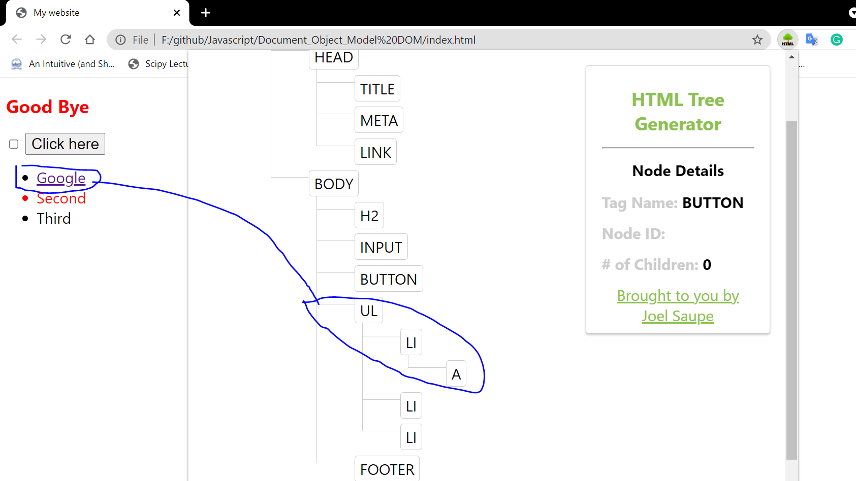

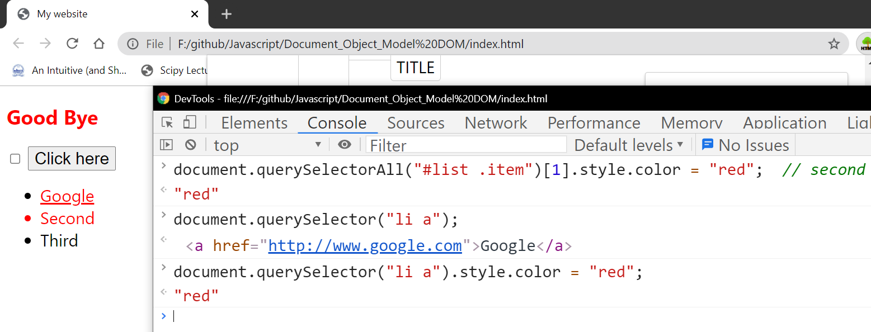

## **Manipulating and changing styles of html elements with java-script**

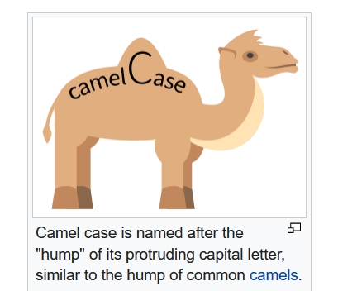

camelCase 🡪 Middle letter must be in caps.  
All the java-script styles will be in camelCase.

CSS

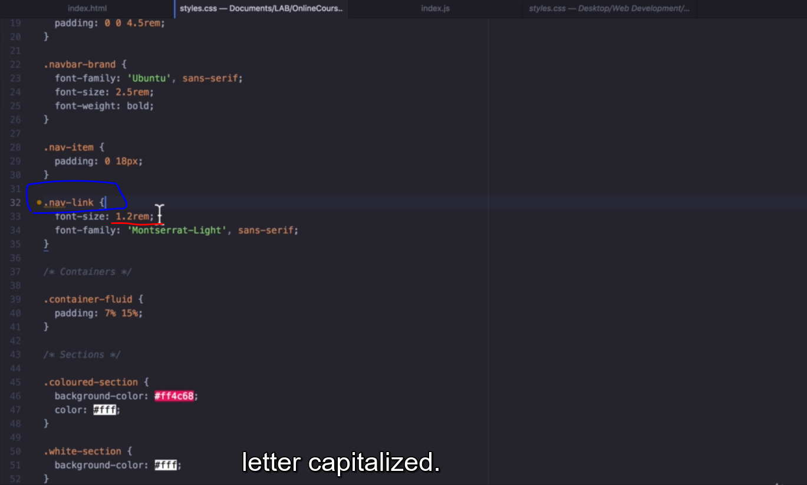

Fontsize value will be given directly. And the class name **.nav-link**

JavaScript   
font size must be given in strings. And all the cases camelCases.

Changing the font-size

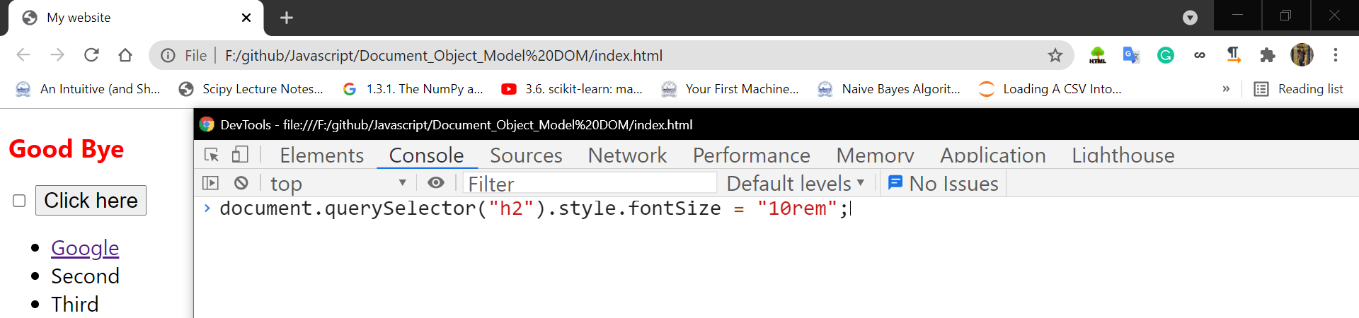

After clicking enter

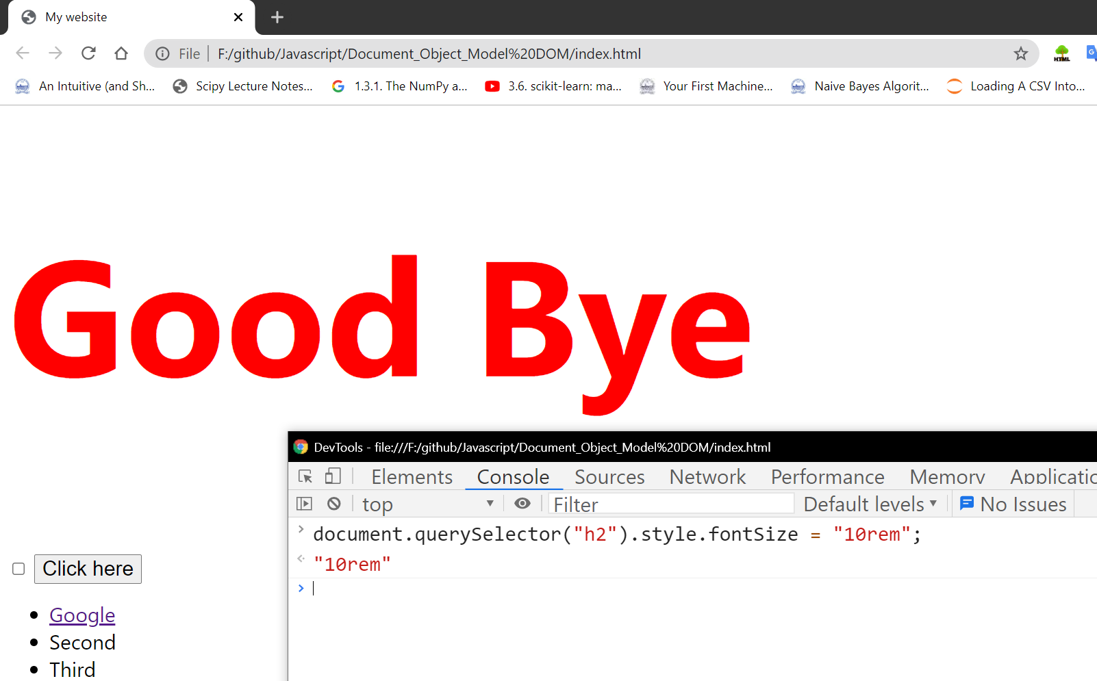

## **Challenge 🡪 Change the background color of click here button**

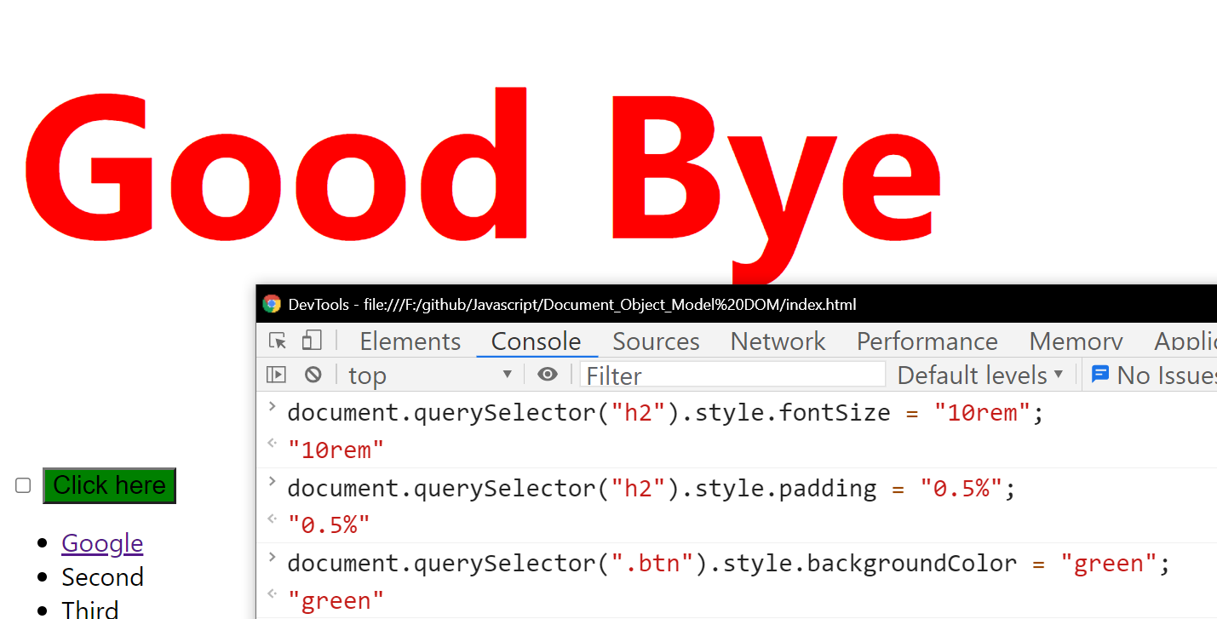

# **Manipulating the Styles**

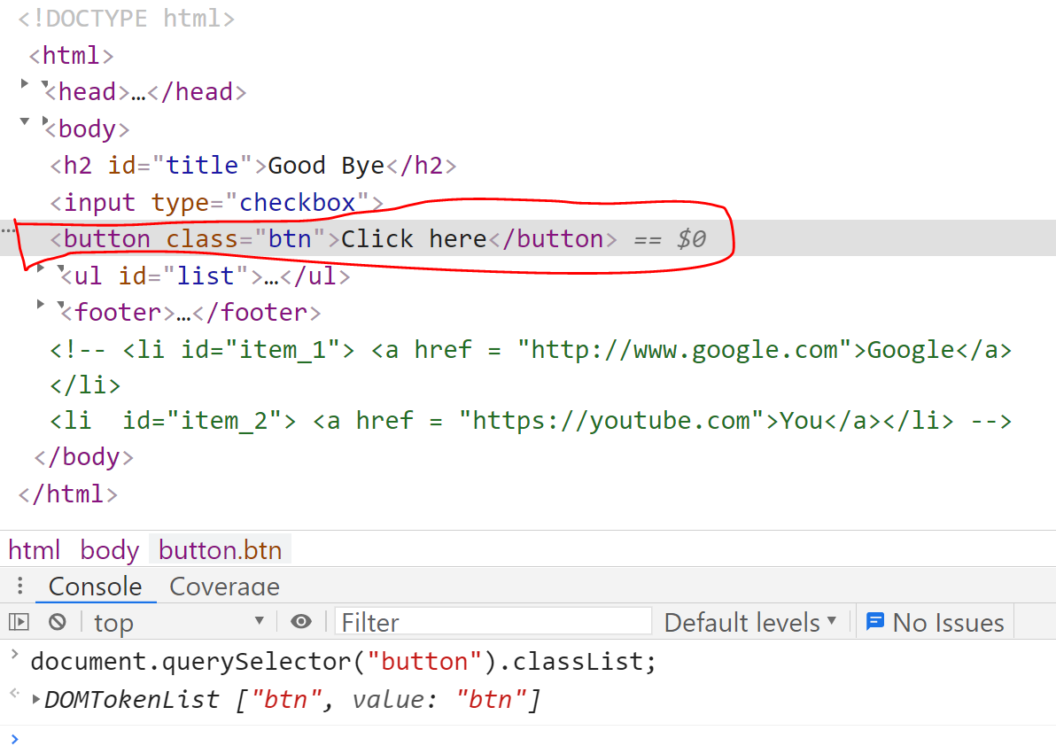

Making the button invisible

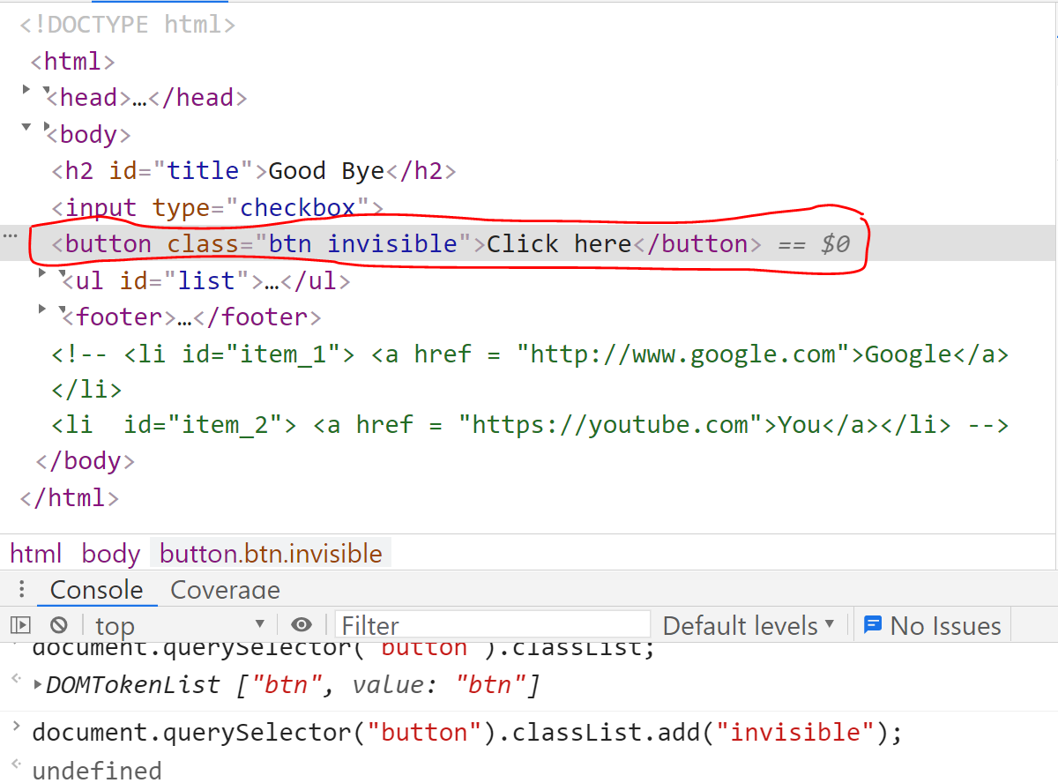

## **Hide the click here button**

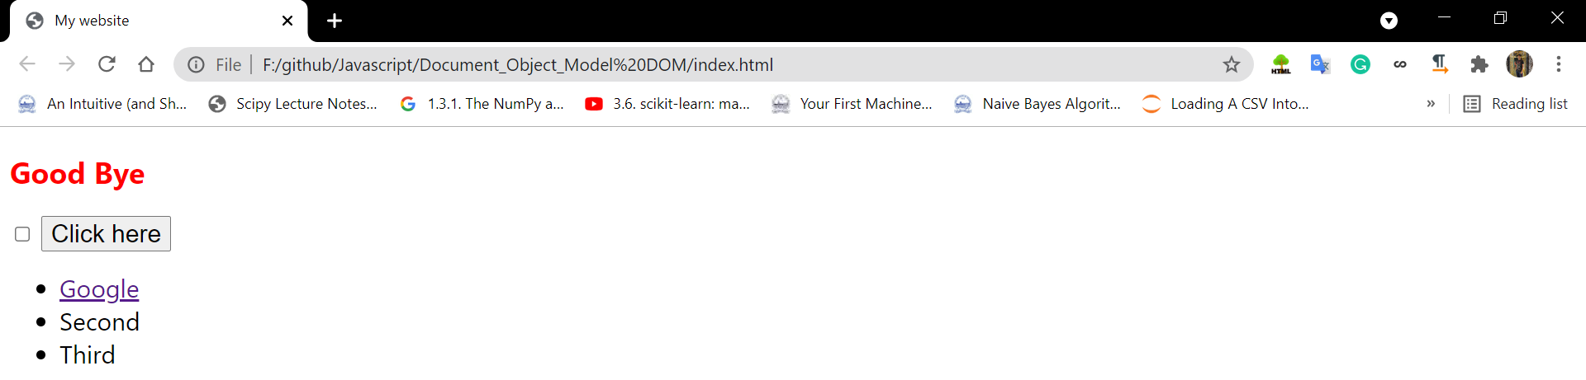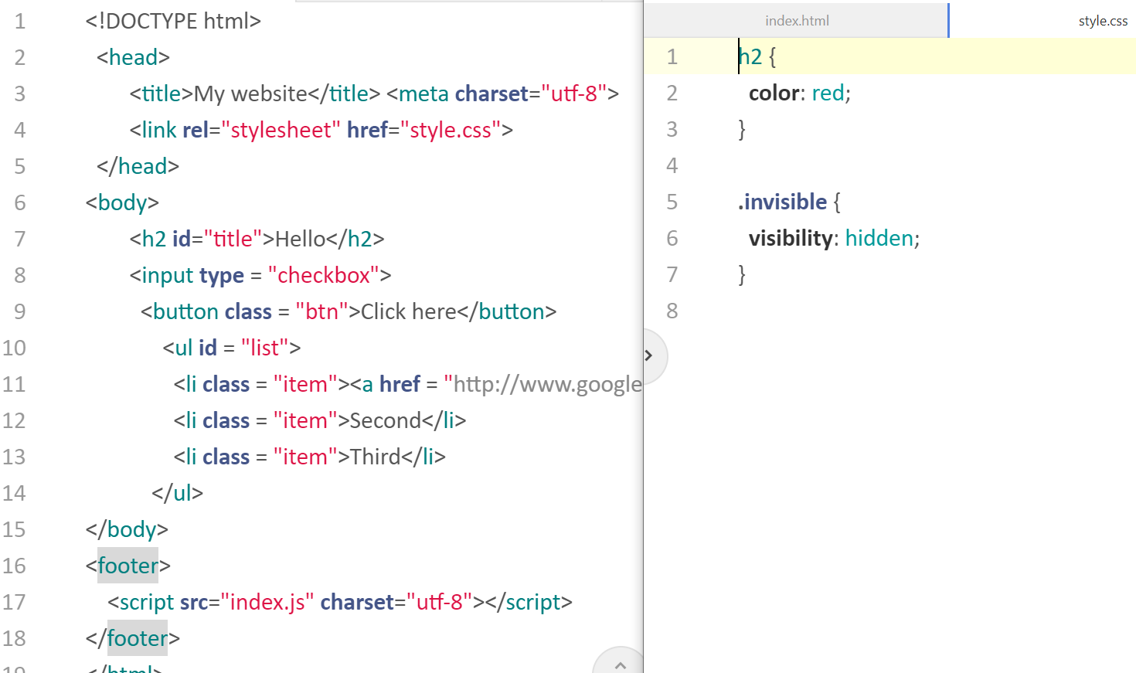

As soon as I add the “invisible” class, click here button is going to disappear.

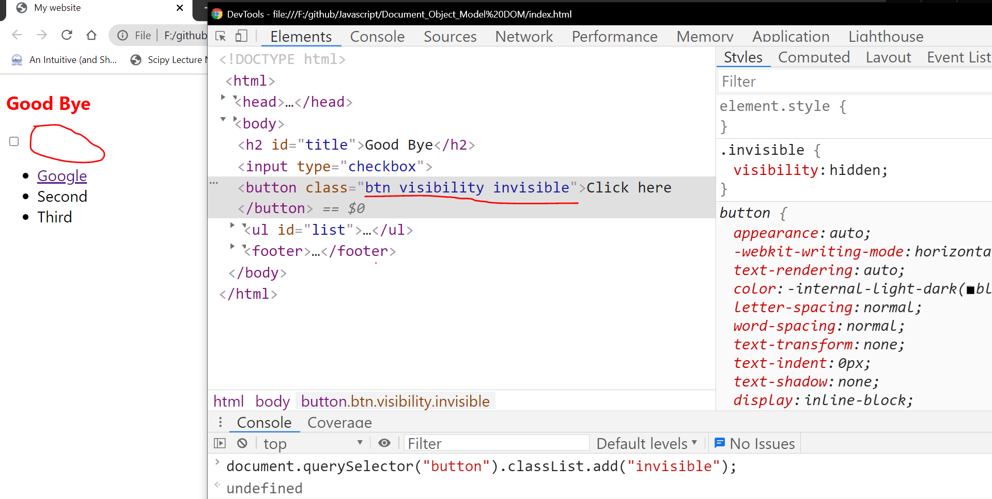

## **Take back the click here button**

As soon as I remove the invisible class, click here button re-appears.

## **Toggle the click button**

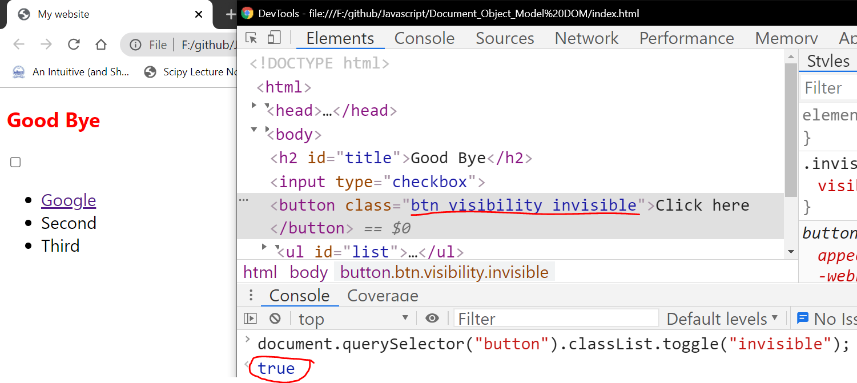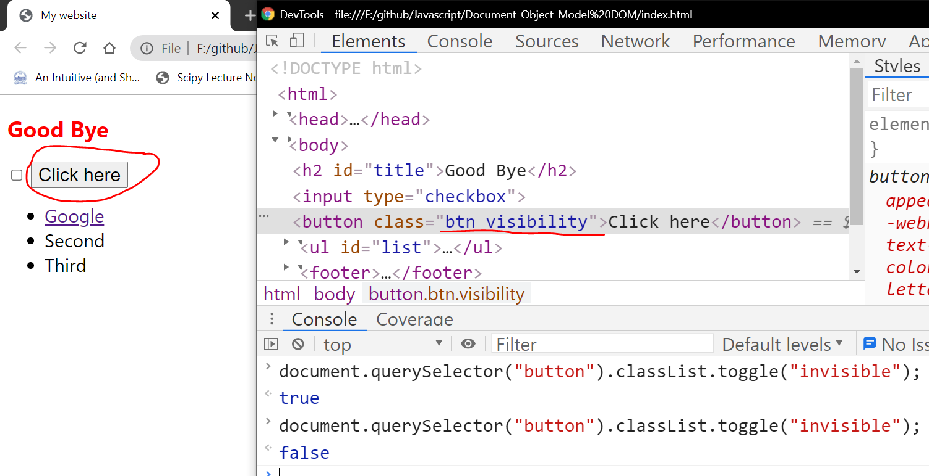

## **Challenge Apply the font to 10rem to the class which-ever required**

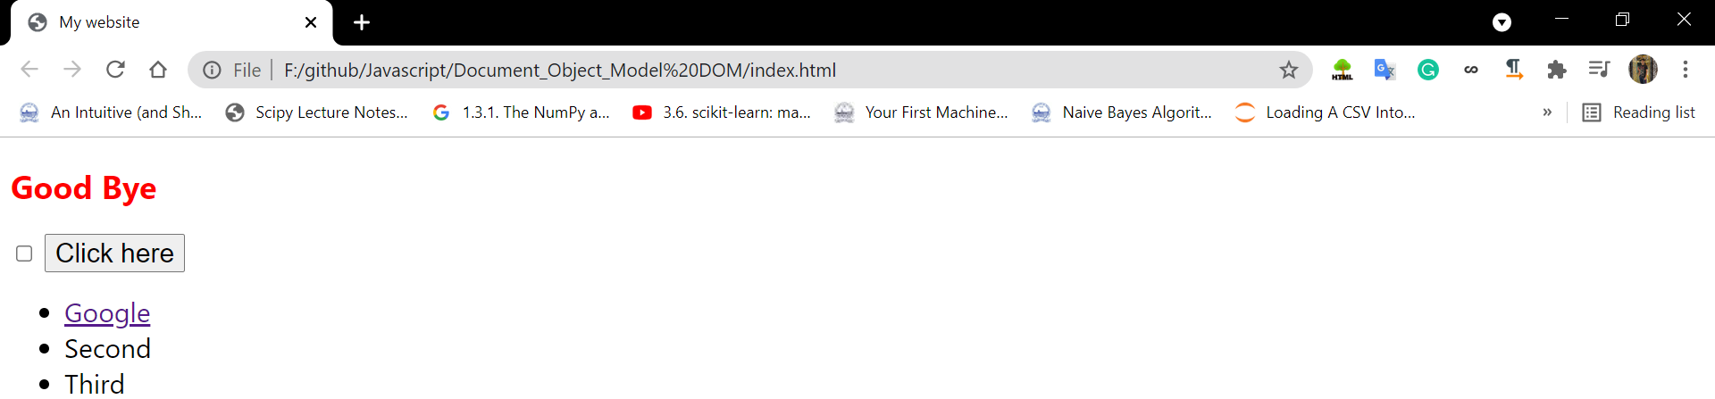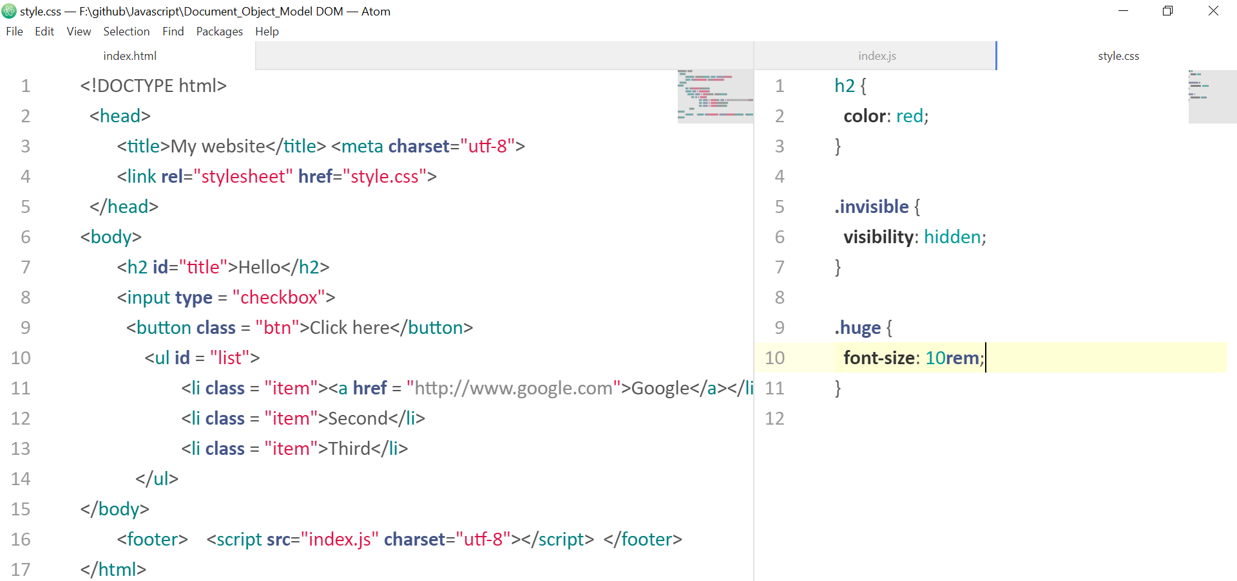

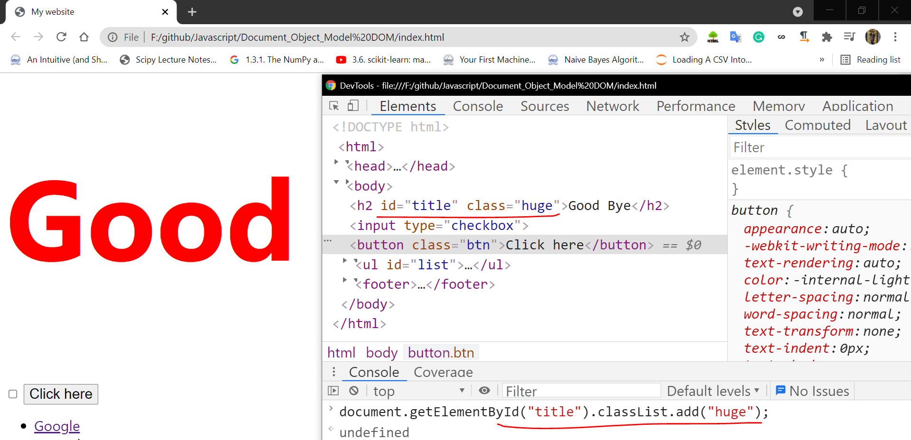

# **Manipulating the text also**

